Web Design & Implementation
Assignment 6

Due: Next Section. (one day before if you submit by email)
Notes: This assignment is individual assignment, every student should complete it by himself.

(10 points) Using HTML, CSS, JavaScript and jQuery. Build a form validation page that contains a set of text input elements and check whether the content of these elements is valid or not when submitting the form. The form should look as following:
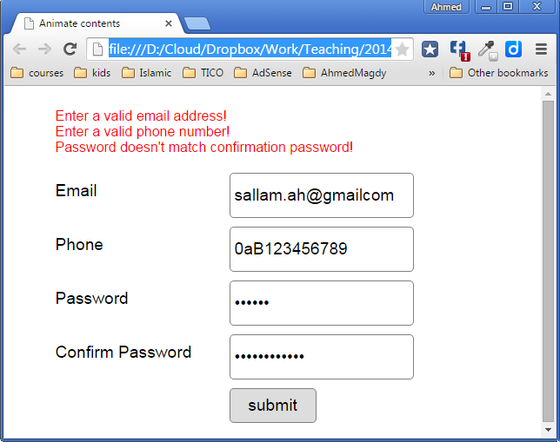
Notes:
- Check standard email validation rules here.
- Check recommended password validation rules here.
- Phone must contain numerical characters only.

